Society derives benefits at the expense of risk taken by individuals
There is nothing wrong in speculation or expecting something from future, we all do. The concept of expectation is intuitive. Basic premise is that you guess about your future profit in case of favourable outcome and loss in case of unfavourable and If your net result is positive you can expect to make money in long term. We also said that stock market is a positive expectation game. So, let us analyse step by step if we can use Casino concept of expectation in stock market???
Law of large numbers

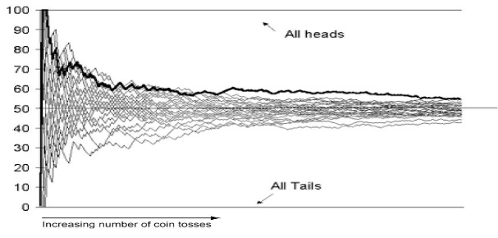In casinos and games/experiment future outcomes have an upper limit and they are known before playing the game. For example, if you roll a fair dice you beforehand know that there are only six possible outcomes. In such games it is a proven that average of an event from a game will approach to expectation. It means that your guess will be quite accurate and such games are friends to the prediction gurus.
Convergence of expectation and average is due to fact that your assumption about the probability of outcomes are quite accurate. Why? Since there are only two possible outcomes in coin toss etc. Let’s assume that you toss coin 1000 times and head comes 300 times and tail comes 700 times, therefore our Average A(H) =300/1000 =.30 and similarly for tail A(T) is .70. Obviously, these values are quite away from ½

Let’s repeat 1000 times more. We repeat Because it is known if allowed infinite times we can realize ½. This set of 1000 toss can unfold in two outcomes Firstly, you again get more tails than heads therefore you A(H) and A(T) will remain what they were but it can also happen that you can get more heads than tails and therefore your A(H) will increase and go towards ½ and you A(T) will decrease

All life is hit and Trial

and go towards ½. Latter case is ideal for us so Do not worry. In former case we have no benefits derived from more tossing so how do we deal with it? Simply go on tossing if you are lucky you can get what you seek at 3000 or 4000 or go on till you die. And in case you die and do not get what you seek please write a will and nominate one person who can carry out the tossing.

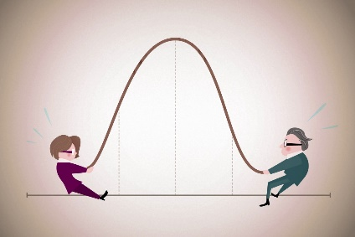
Let’s explore one more hidden thing. We assume that we are very lucky and after 5000 toss of a coin we get A(H) =.40 and A(T)=.60. Outcomes are quite near. Error is 20 percent. Suppose that at 5001 toss you get tail then A(T) is .601 and therefore change in A(T) is .16% or. 0016.Negligible.
You can argue so what is hidden here? Wisdom is that no single outcome at any point during the experiment can change your average or probability or A(T) or A(H) significantly.
So, can we apply this expectation process ditto to stock markets? Answer is big NO. why?
1)Outcomes are not known; 2) price has no known upper limit; 3) Individual return can unsettle your average

Mistake of law of large numbers
Individuals does not matter but average.

