Once chosen throw the ideal in the river and excel on process
Expectation
Finance has borrowed too much from games of chances/casinos to explain behaviour of prices but in vain. To learn how to do things right is equivalent to learn how not to ruin things. Our aim is therefore to inspect the methods of modern finance Theory and valuation and criticise them wherever its necessary and jot down how not to fall for those illusions. Meanwhile building our own approach compatible with our own behaviour.
The basic concept of finance is that your expected return from a game of chance should be positive in order to play the game. Let’s understand what it means and how much this concept is useful to us?
Imagine we open a casino wherein we offer our visitors a chance to bet on toss of a Fair coin. If head shows up he wins 2 rupee and if it comes tails he loses one rupee. Mr Normal walks in our casino and ask us to start the game. Let us pause here real events of our casino and just try to learn what are Mr. Normal inclinations towards the game of chances and how he developed them?

 Mr. Normal is Ph.D. in statistics and has always been a bright student. During his academic time he learns how to predict future outcomes of an event from statistical methods. One such method points out that an event with known outcomes if repeated infinite times then the average of that particular event will moves towards probability of that particular event with an error rate which decreases with every repetition of game. Not convinced he decides to do and observe the results in practise.
He figure out that if he tosses a coin then there are only two possible outcomes namely head and tail. He further assume that there is no evidence to assume chances of heads are more than tail so he concludes that both outcomes are likely and probability of each outcome is ½. He starts tossing the coin and records the outcomes. Let’s get into His excel file Illusion of finance(Part 1).xlsx . He becomes confident that theory he learned works in practise also.

Think before you leap not while you leap

 At this point he comes to know about our casino. He decides to make some bucks . He figures out that 50 percent times head will appear and rest tail. So he can make a profit of one rupee average per head and can make a loss of .50 rupee on average if it is tail. So he expected to make a net profit of .50 rupee on average per game.
Let’s resume our real events in casino. Outcomes up to ten tosses are +2,+2,-1,+2,-1,-1,-1,-1,-1,+2. His net equity becomes 2. He further plays ten more times. Outcomes are -1,-1,-1,-1,-1,+2,+2,-1,-1,-1. His net equity becomes -2. He further ask us to toss the coin ten more times but I step in to refuse.
 He becomes confused because as per his theory he should have cash upon 10 rupee but instead he gave out 2 rupee. As always he soothes himself by thinking that only if would have played more games.
He comes after a week and extract a deal to play 50 rounds of game. I do not get the logic and give my word. This time head turns out 26 times and tails 24 times. His equity becomes net 28 rupee. Glad he comes out smiling.
I reflect at what just happened. Next day I change the terms of game. I state that I will charge a upfront fee of rupee 1.10 and if head comes I will pay rupee 2 and if tail comes I will pay nothing.

When in doubt get out
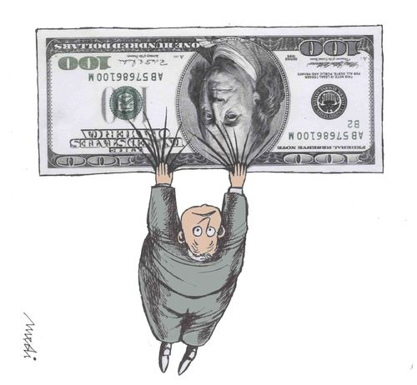 More than eager to try this new game our Mr. Normal walks again casino and get me into deal of exactly fifty games. This time head turns out to be 26 times and Tails comes out to be 24 times. He ends up losing 3 rupee.

Let’s analyse what is happening here in all three cases. Expectation of first game is positive which means that if allowed to play game infinite times you can make profit. Expectation is calculated as: probability of head*reward-probability of tail*loss. This implies 1/2*2 - 1/2*1 = .5.
In first case it is expected to make a profit of .5 on average so it follows we can make a profit of .5*20 = 10 rupee in 20 games but it is misleading. Your average will comes .5 when you are allowed to play infinite times but I refused to offer any further chance to Mr. Normal
In third game expectation is negative therefore even fifty chances gave him negative result.
Conclusion is when a positive expectation game if played infinite would yield profit with certainty. Contrary in negative expectation game if played infinite would make you bankrupt with certainty.
In casinos games are designed to be of negative expectation so more you play more is your chances of losing your money. Next time when you go in any casino and get some early wins then walk out otherwise on average your wins would be wiped out by the losses.
So our question can be what type of game is stock market?. We believe it is a positive expectation game .It means longer you stay more your chances of being in profits.

